**Bookatable Acceptance Test ReadMe File – by Jenella Marriott**

Download Eclipse IDE from:

<http://www.eclipse.org/downloads/packages/eclipse-ide-java-ee-developers/marsr>

Once installed click on the Eclipse icon to open



Create a new workspace by browsing and creating a new folder, then click OK

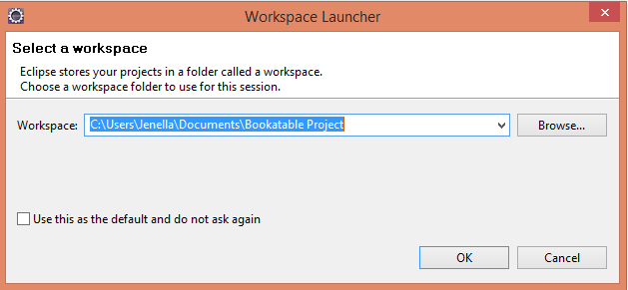

Click on File > Import

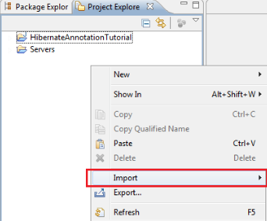

Select the Dropdown under General, then select ‘Existing Projects ito Workspace’, then click Next

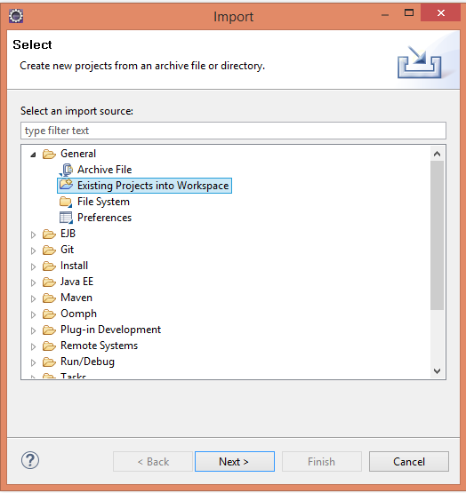

Click Browse

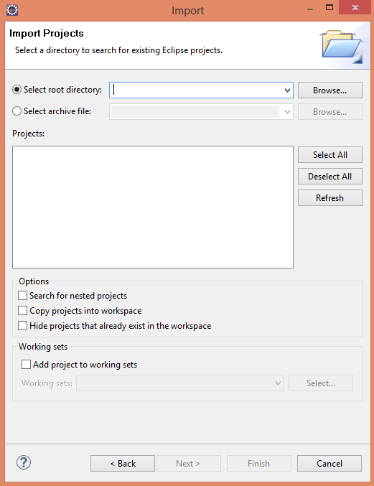

Select the Selenium Project Folder from your extracted zip file and click OK.

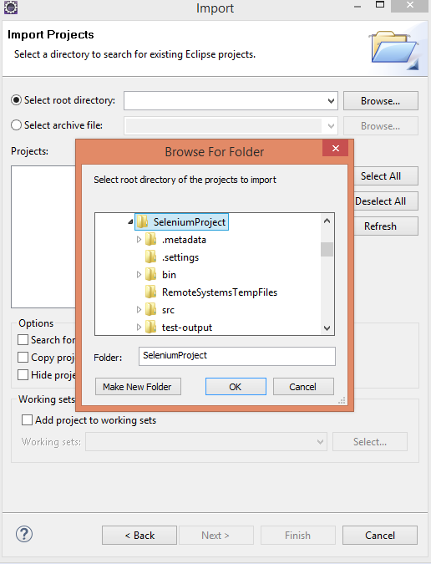

Then click Finish.

The project will be in your Project Explorer.

Expand Selenium Project > src > FunctionalTests and double click bookatable.java to open.

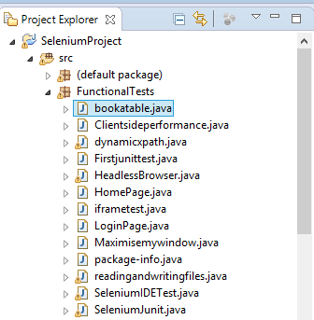

Click on the  Play icon to run the tests..

